

**MAHARASTRA STATE BOARD Of TECHNICAL**

**EDUCATION**

Government Polytechnic Osmanabad

**Certificate**

This is to certify that the micro project title –

**“ Simple Calculator Design.”**

Submitted by Roll no: 29 of CO4I of Fourth Semester of Diploma in Computer Engineering has Completed Micro Project Work Satisfactory in the course GUI application development using GAD (22034)] for the Academic Year 2023-2024 As Prescribed in the Curriculum

Place: Osmanabad

Date: / / 2023 Enrollment No:

Name:

1) Kshirsagar Yogesh Dattatraya 2)2101180277

Exam Seat No:

396417

Subject Teacher Head of Department Principal

**MAHARASHTRA STATE BOARD OF TECHNICAL**

**EDUCATION**



**Government Polytechnic Osmanabad**

|  |  |  |  |
| --- | --- | --- | --- |
| Roll No | Name | Enrolment No | Exam Seat No |
|  |  |  |  |
| 29 | Kshirsagar Yogesh Dattatraya | 2101180277 | 396417 |
|  |  |  |  |

**Participates**

**Under the Guidance**

**Mr S.D.PORE**

**Acknowledgment**

I am grateful to Almighty God for giving me the strength, knowledge and understanding to complete this project. His love has been more than sufficient to keep and sustain me.

My profound gratitude goes to my wonderful supervisor, Mr S.D.PORE sir for him invaluable support, patience, time and guidance in seeing me to the completion of this research work. Also, my gratitude goes to my head of department Mr. P.J. Bansode sir who patiently saw me to the completion of this research work.

I extend gratitude and appreciation to my lecturers Mr S.D.PORE sir in department who have taught me at one point or the other. May God continue to bless, protect and guide you all.

I also wish to acknowledge the great support of my parents, siblings who have been a source of inspiration towards my academic pursuit. God bless you all.

I will not cease to acknowledge the support of my friends: Samarth , Purushottam ,Om, and Yash . God bless you all

Student Name:

1) Kshirsagar Yogesh Dattatraya

**Index**

|  |  |  |
| --- | --- | --- |
| **Sr.No** | **Index Topic** | **PageNo** |
| 1 | Title of Micro-Project | 5 |
| 2 | Rational | 5 |
| 3 | Aim of the Micro-Project | 5 |
| 4 | Course Outcomes | 5 |
| 6 | Resources Required | 5 |
| 7 | INTRODUCTION TO VB.net | 6 |
| 8 | Features of VB.net | 7 |
| 9 | Tools in VB.net | 8 |
| 10 | What is GUI ? | 9 |
| 11 | Elements in Graphical User Interface | 10 |
| 12 | Benefits of GUI | 11 |
| 13 | CODE | 12 |
| 14 | OUTPUT | 18 |
| 15 | Skill Developed / Learning outcome of this Micro-Project: | 22 |
| 16 | Conclusion | 22 |
| 17 | Reference: | 22 |

**Micro-Project Report**

* **Title of Micro-Project:**

Simple Calculator Design.

* **Rational:**

Software Engineering is the foundation for professional processes to be followed involving principles, techniques, and practices for software development. The course provides a framework for software professionals for building quality assured software products. It enables us to blend the domain specific knowledge with the programming skills to create quality software products.

* **Aim of the Micro-Project:**

To prepare a simple calculator design using GUI(Graphical User Interface)application development using GAD.

* **Course Outcomes:**

1. .Use visual studio IDE to design application.
2. use data binding in GUI application.
3. Develop application using form control and its events.

* **Resources Required :**

|  |  |  |
| --- | --- | --- |
| **Sr. No** | **Name of Resource** | **Specification** |
| 1 | Hardware:(personal computer) | i3, RAM 8 GB |
| 2 | Operating System | Window 7 |
| 3 | Software | Visual Studio Express |

**INTRODUCTION TO VB.net**

The VB.NET stands for Visual Basic. Network Enabled Technologies. It is a simple, high-level, object-orientedprogramming language developed by Microsoft in 2002. It is a successor of Visual Basic 6.0, that is implemented on the Microsoft .NET framework. Furthermore, it supports the OOPs concept, such as abstraction, encapsulation, inheritance, and polymorphism. Therefore, everything in the VB.NET language is an object, including all primitive data types (Integer, String, char, long, short, Boolean, etc.), user-defined data types, events, and all objects that inherit from its base class. It is not a case sensitive language, whereas, c++ ,java and C# are case sensitive language.

Applications built using the VB.NET language are very reliable and scalable, relying on the .NET Framework to access all libraries that help to execute a VB.NET program. With this language, you can develop a fully object-oriented application that is similar to an application created through another language such as C++, Java, or c#. In addition, applications or programs of VB.NET are not only running on the windows operating system but can also run on Linux or Mac OS.

The VB.NET language is designed in such a way that any new beginner or novice and the advanced programmer can quickly develop a simple, secure, robust, high performance of web, windows, console, and mobile application running on .net framework..

**Features of VB.net –**

* 1. It is an object-oriented programming language that follows various oops concepts such as abstraction, encapsulation, inheritance, and many more. It means that everything in VB.NET programming will be treated as an object.
  2. This language is used to design user interfaces for window, mobile, and web-based applications.
  3. It is not a case sensitive language like other languages such as C++, java, etc.
  4. It supports Boolean condition for decision making in programming.
  5. It also supports the multithreading concept, in which you can do multiple tasks at the same time.
  6. It provides simple events management in .NET application.
  7. A Window Form enables us to inherit all existing functionality of form that can be used to create a new form. So, in this way, it reduced the code complexity.
  8. It uses an external object as a reference that can be used in a VB.NET application.
  9. Automatic initialized a garbage collection.
  10. It follows a structured and extensible programming language for error detection and recovery.
  11. Conditional compilation and easy to use generic classes.
  12. It is useful to develop web, window, and mobile applications.

**Tools in VB.net**

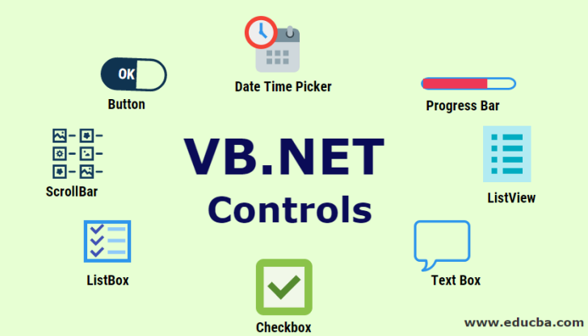

**What is GUI ?**

GUI [ Graphical user Interface ] is an interface that allows users to interact with different electronic devices using icons and other visual indicators. The graphical user interfaces were created because command line interfaces were quite complicated and it was difficult to learn all the commands in it.

In today’s times, graphical user interfaces are used in many devices such as mobiles, MP3 players, gaming devices, smartphones etc.

The below diagram provides the position of the graphical user interface with respect to the computer system −

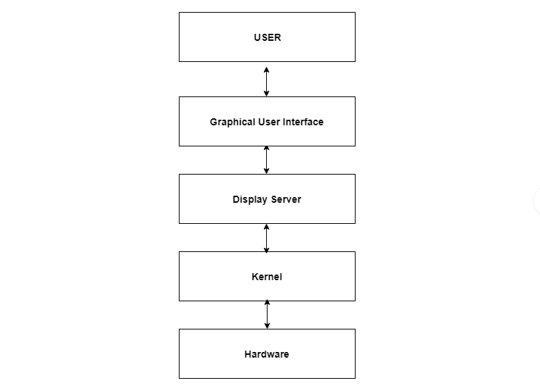

## Elements in Graphical User Interface

Graphical User Interface makes use of visual elements mostly. These elements define the appearance of the GUI. Some of these are described in detail as follows −

## Window

This is the element that displays the information on the screen. It is very easy to manipulate a window. It can be opened or closed with the click of an icon. Moreover, it can be moved to any area by dragging it around.In a multitasking environment, multiple windows can be open at the same time, all of them performing different tasks.

There are multiple types of windows in a graphical user interface, such as container window, browser window, text terminal window, child window, message window etc.

## Menu

A menu contains a list a choices and it allows users to select one from them. A menu bar is displayed horizontally across the screen such as pull down menu. When any option is clicked in this menu, then the pull down menu appears.

Another type of menu is the context menu that appears only when the user performs a specific action. An example of this is pressing the right mouse button. When this is done, a menu will appear under the cursor.

## Icon

Files, programs, web pages etc. can be represented using a small picture in a graphical user interface. This picture is known as an icon. Using an icon is a fast way to open documents, run programs etc. because clicking on them yields instant access.

## Controls

Information in an application can be directly read or influences using the graphical control elements. These are also known as widgets. Normally, widgets are used to display lists of similar items, navigate the system using links, tabs etc. and manipulating data using check boxes, radio boxes etc.

## Tabs

A tab is associated with a view pane. It usually contains a text label or a graphical icon. Tabs are sometimes related to widgets and multiple tabs allow users to switch between different widgets. Tabs are used in various web browsers such as Internet Explorer, Firefox, Opera, Safari etc. Multiple web pages can be opened in a web browser and users can switch between them using tabs

**Benefits of GUI :-**

1. Easy to use.
2. Attractive.
3. Easy to communicate.
4. Provide shortcut.
5. Allows for multitasking.

**CODE**

Public Class Form1

Dim n1 As Integer

Dim n2 As Integer

Dim secondNumber As Boolean = False

Dim operation As Integer = 0

Private Sub Button11_Click(sender As Object, e As EventArgs) Handles Button11.Click

If secondNumber = True Then

TextBox1.Text = TextBox1.Text + "7"

TextBox2.Text = TextBox2.Text + "7"

Else

TextBox1.Text = TextBox1.Text + "7"

End If

End Sub

Private Sub Button12_Click(sender As Object, e As EventArgs) Handles Button12.Click

If secondNumber = True Then

TextBox1.Text = TextBox1.Text + "8"

TextBox2.Text = TextBox2.Text + "8"

Else

TextBox1.Text = TextBox1.Text + "8"

End If

End Sub

Private Sub Button13_Click(sender As Object, e As EventArgs) Handles Button13.Click

If secondNumber = True Then

TextBox1.Text = TextBox1.Text + "9"

TextBox2.Text = TextBox2.Text + "9"

Else

TextBox1.Text = TextBox1.Text + "9"

End If

End Sub

Private Sub Button14_Click(sender As Object, e As EventArgs) Handles Button14.Click

If secondNumber = True Then

TextBox1.Text = TextBox1.Text + "4"

TextBox2.Text = TextBox2.Text + "4"

Else

TextBox1.Text = TextBox1.Text + "4"

End If

End Sub

Private Sub Button15_Click(sender As Object, e As EventArgs) Handles Button15.Click

If secondNumber = True Then

TextBox1.Text = TextBox1.Text + "5"

TextBox2.Text = TextBox2.Text + "5"

Else

TextBox1.Text = TextBox1.Text + "5"

End If

End Sub

Private Sub Button16_Click(sender As Object, e As EventArgs) Handles Button16.Click

If secondNumber = True Then

TextBox1.Text = TextBox1.Text + "6"

TextBox2.Text = TextBox2.Text + "6"

Else

TextBox1.Text = TextBox1.Text + "6"

End If

End Sub

Private Sub Button17_Click(sender As Object, e As EventArgs) Handles Button17.Click

If secondNumber = True Then

TextBox1.Text = TextBox1.Text + "1"

TextBox2.Text = TextBox2.Text + "1"

Else

TextBox1.Text = TextBox1.Text + "1"

End If

End Sub

Private Sub Button18_Click(sender As Object, e As EventArgs) Handles Button18.Click

If secondNumber = True Then

TextBox1.Text = TextBox1.Text + "2"

TextBox2.Text = TextBox2.Text + "2"

Else

TextBox1.Text = TextBox1.Text + "2"

End If

End Sub

Private Sub Button19_Click(sender As Object, e As EventArgs) Handles Button19.Click

If secondNumber = True Then

TextBox1.Text = TextBox1.Text + "3"

TextBox2.Text = TextBox2.Text + "3"

Else

TextBox1.Text = TextBox1.Text + "3"

End If

End Sub

Private Sub Button20_Click(sender As Object, e As EventArgs) Handles Button20.Click

If secondNumber = True Then

TextBox1.Text = TextBox1.Text + "0"

TextBox2.Text = TextBox2.Text + "0"

Else

TextBox1.Text = TextBox1.Text + "0"

End If

End Sub

Private Sub Button3_Click(sender As Object, e As EventArgs) Handles Button3.Click

Dim N As Integer

If TextBox1.Text = "" Then

TextBox1.Text = ""

Else

N = Val(TextBox1.Text)

If TextBox1.Text.Length = N.ToString().Length Then

n1 = TextBox1.Text

secondNumber = True

operation = 1

TextBox1.Text = TextBox1.Text + "/"

End If

End If

If TextBox2.Text = "" Then

Else

If operation > 0 Then

If operation = 1 Then

TextBox1.Text = n1 / Val(TextBox2.Text)

End If

If operation = 2 Then

TextBox1.Text = n1 - Val(TextBox2.Text)

End If

If operation = 3 Then

TextBox1.Text = n1 * Val(TextBox2.Text)

End If

If operation = 4 Then

TextBox1.Text = n1 + Val(TextBox2.Text)

End If

TextBox2.Text = ""

n1 = Val(TextBox1.Text)

TextBox1.Text = TextBox1.Text + "/"

operation = 1

End If

End If

End Sub

Private Sub Button4_Click(sender As Object, e As EventArgs) Handles Button4.Click

Dim N As Integer

If TextBox1.Text = "" Then

TextBox1.Text = ""

Else

N = Val(TextBox1.Text)

If TextBox1.Text.Length = N.ToString().Length Then

n1 = TextBox1.Text

secondNumber = True

operation = 2

TextBox1.Text = TextBox1.Text + "-"

End If

End If

If TextBox2.Text = "" Then

Else

If operation > 0 Then

If operation = 1 Then

TextBox1.Text = n1 / Val(TextBox2.Text)

End If

If operation = 2 Then

TextBox1.Text = n1 - Val(TextBox2.Text)

End If

If operation = 3 Then

TextBox1.Text = n1 * Val(TextBox2.Text)

End If

If operation = 4 Then

TextBox1.Text = n1 + Val(TextBox2.Text)

End If

TextBox2.Text = ""

n1 = Val(TextBox1.Text)

TextBox1.Text = TextBox1.Text + "-"

operation = 2

End If

End If

End Sub

Private Sub Button5_Click(sender As Object, e As EventArgs) Handles Button5.Click

Dim N As Integer

If TextBox1.Text = "" Then

TextBox1.Text = ""

Else

N = Val(TextBox1.Text)

If TextBox1.Text.Length = N.ToString().Length Then

n1 = TextBox1.Text

secondNumber = True

operation = 3

TextBox1.Text = TextBox1.Text + "x"

End If

End If

If TextBox2.Text = "" Then

Else

If operation > 0 Then

If operation = 1 Then

TextBox1.Text = n1 / Val(TextBox2.Text)

End If

If operation = 2 Then

TextBox1.Text = n1 - Val(TextBox2.Text)

End If

If operation = 3 Then

TextBox1.Text = n1 * Val(TextBox2.Text)

End If

If operation = 4 Then

TextBox1.Text = n1 + Val(TextBox2.Text)

End If

TextBox2.Text = ""

n1 = Val(TextBox1.Text)

TextBox1.Text = TextBox1.Text + "x"

operation = 3

End If

End If

End Sub

Private Sub Button6_Click(sender As Object, e As EventArgs) Handles Button6.Click

Dim N As Integer

If TextBox1.Text = "" Then

TextBox1.Text = ""

Else

N = Val(TextBox1.Text)

If TextBox1.Text.Length = N.ToString().Length Then

n1 = TextBox1.Text

secondNumber = True

operation = 4

TextBox1.Text = TextBox1.Text + "+"

End If

End If

If TextBox2.Text = "" Then

Else

If operation > 0 Then

If operation = 1 Then

TextBox1.Text = n1 / Val(TextBox2.Text)

End If

If operation = 2 Then

TextBox1.Text = n1 - Val(TextBox2.Text)

End If

If operation = 3 Then

TextBox1.Text = n1 * Val(TextBox2.Text)

End If

If operation = 4 Then

TextBox1.Text = n1 + Val(TextBox2.Text)

End If

TextBox2.Text = ""

n1 = Val(TextBox1.Text)

TextBox1.Text = TextBox1.Text + "+"

operation = 4

End If

End If

End Sub

Private Sub Button7_Click(sender As Object, e As EventArgs) Handles Button7.Click

If operation > 0 Then

If operation = 1 Then

TextBox1.Text = n1 / Val(TextBox2.Text)

End If

If operation = 2 Then

TextBox1.Text = n1 - Val(TextBox2.Text)

End If

If operation = 3 Then

TextBox1.Text = n1 * Val(TextBox2.Text)

End If

If operation = 4 Then

TextBox1.Text = n1 + Val(TextBox2.Text)

End If

TextBox2.Text = ""

operation = 0

End If

End Sub

Private Sub Button1_Click(sender As Object, e As EventArgs) Handles Button1.Click

TextBox1.Text = ""

TextBox2.Text = ""

operation = 0

End Sub

End Class

**OUTPUT**

Addition

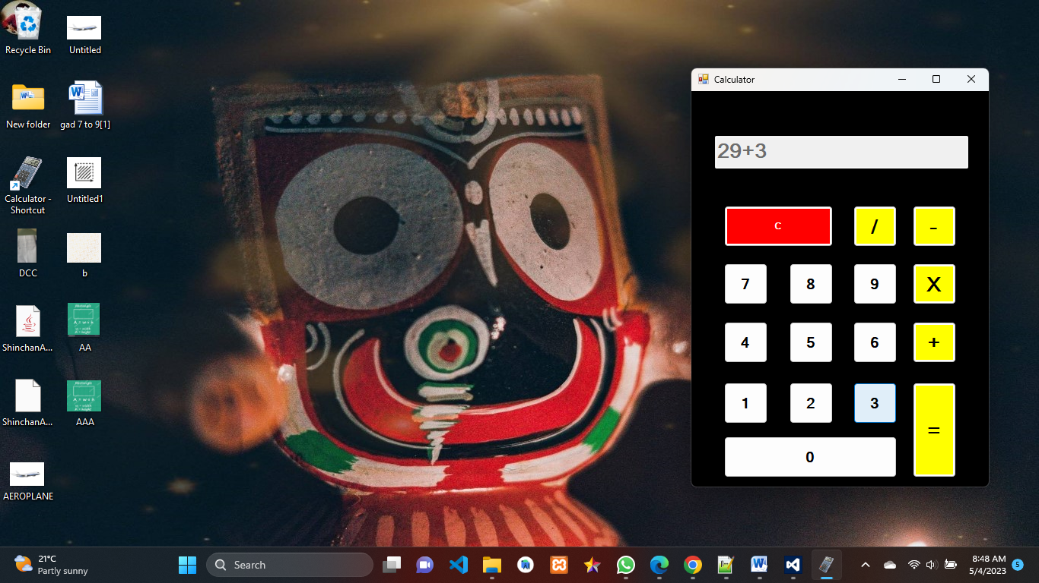

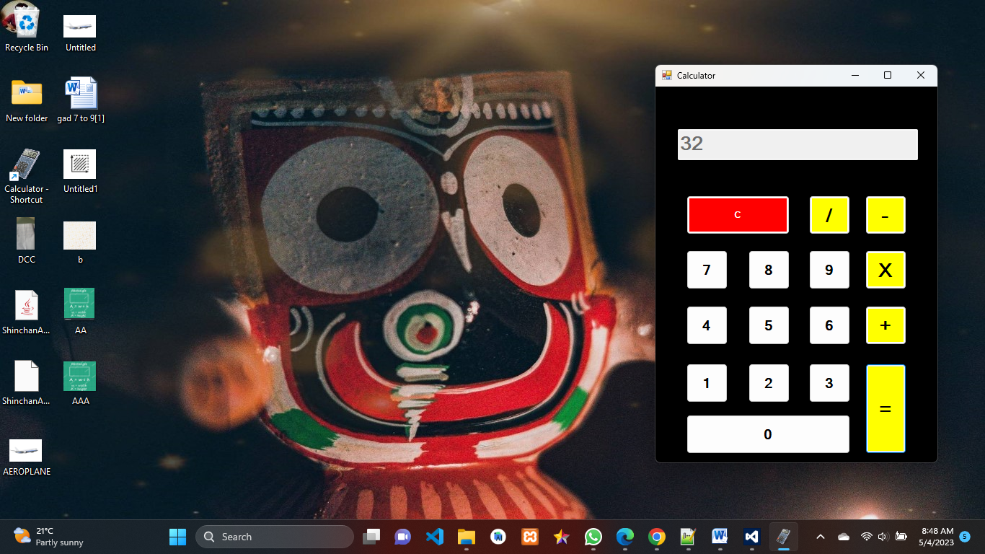

Substraction

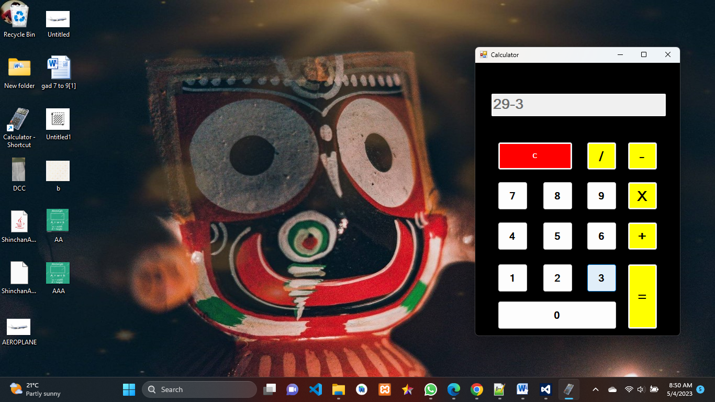

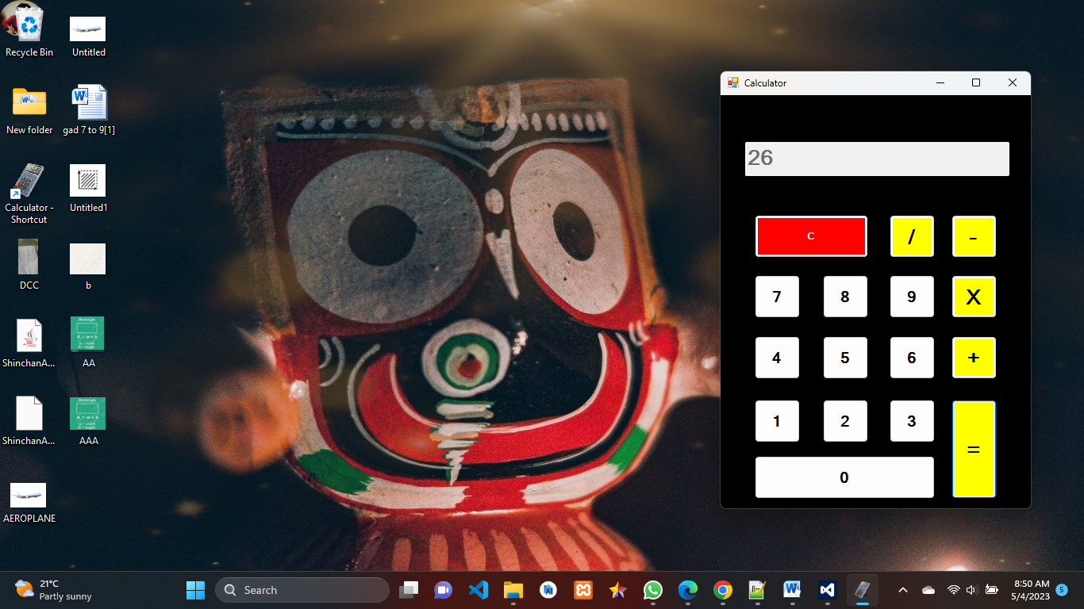

Multiplication

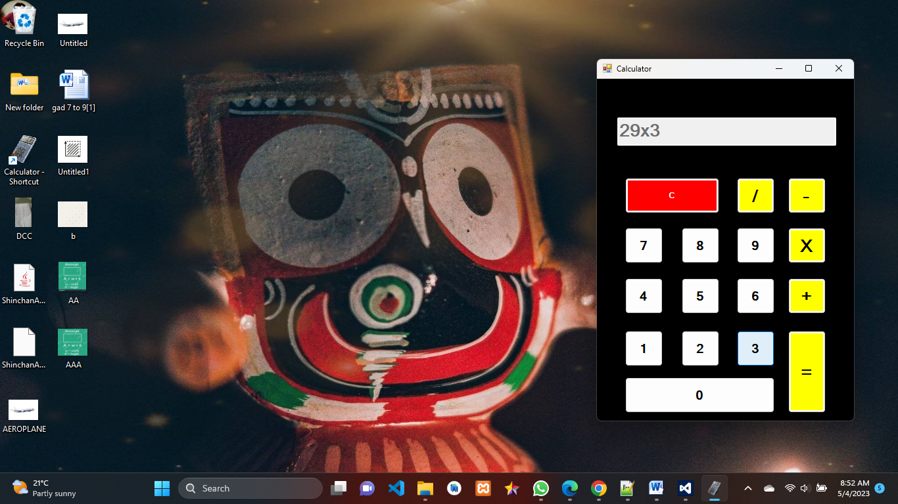

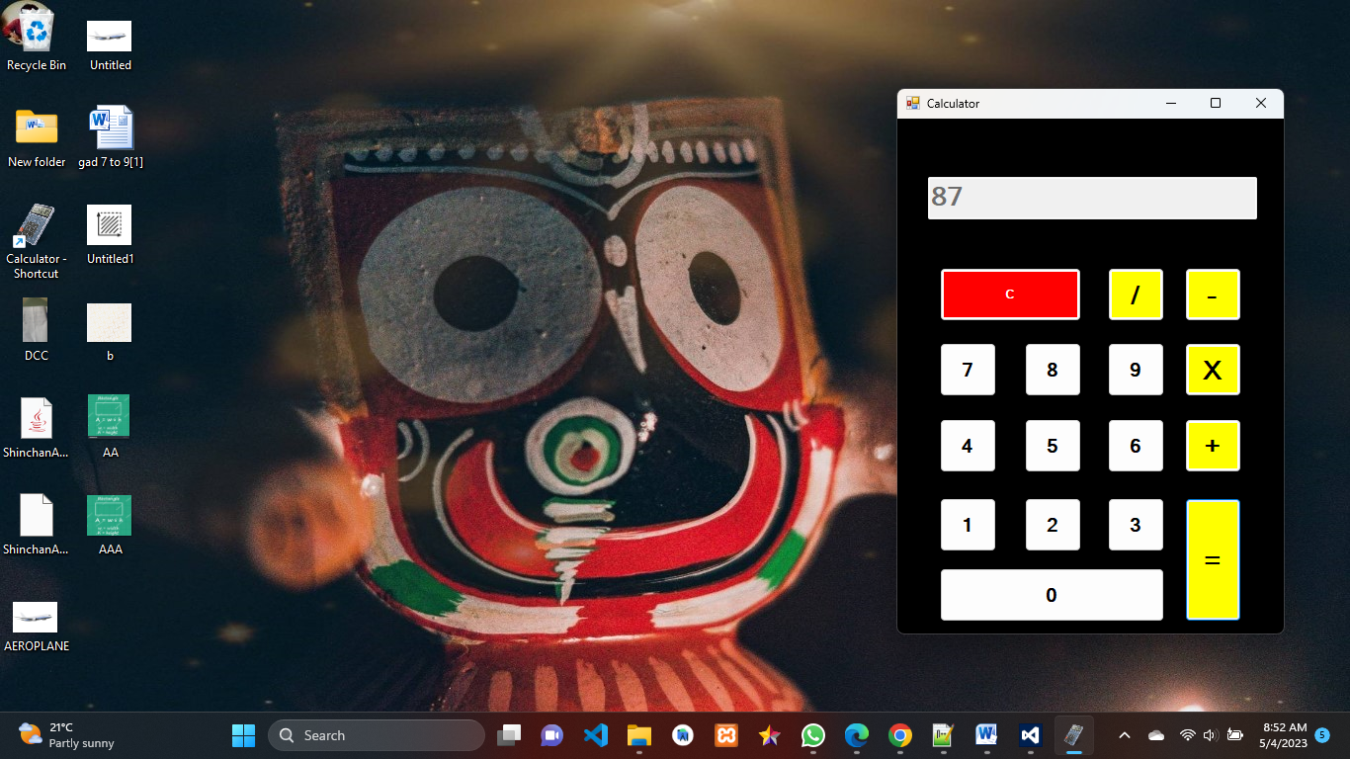

Division

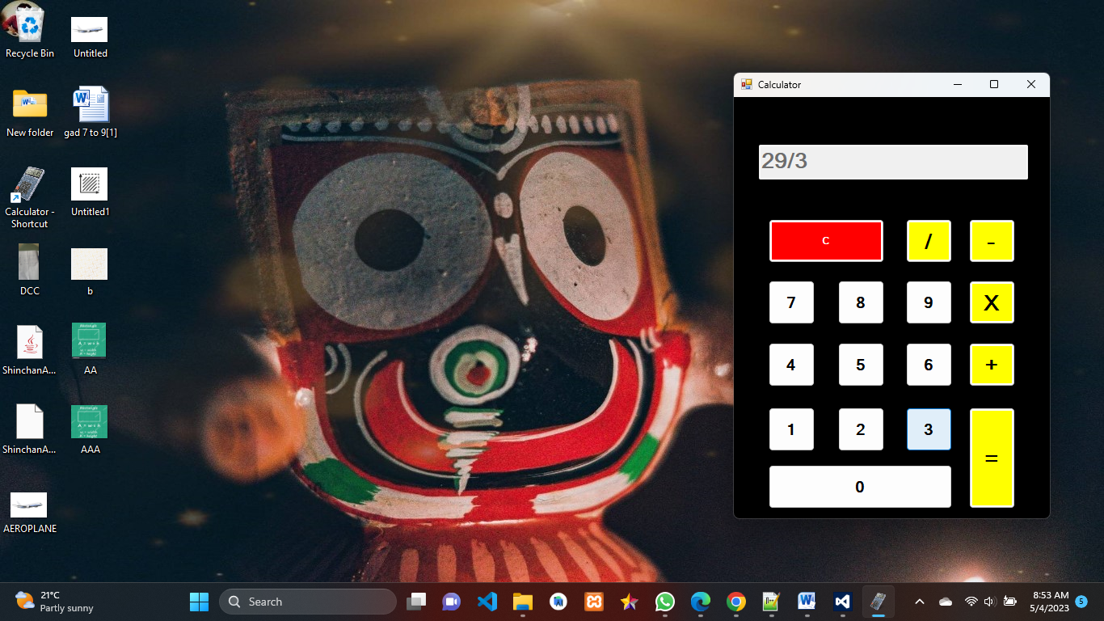

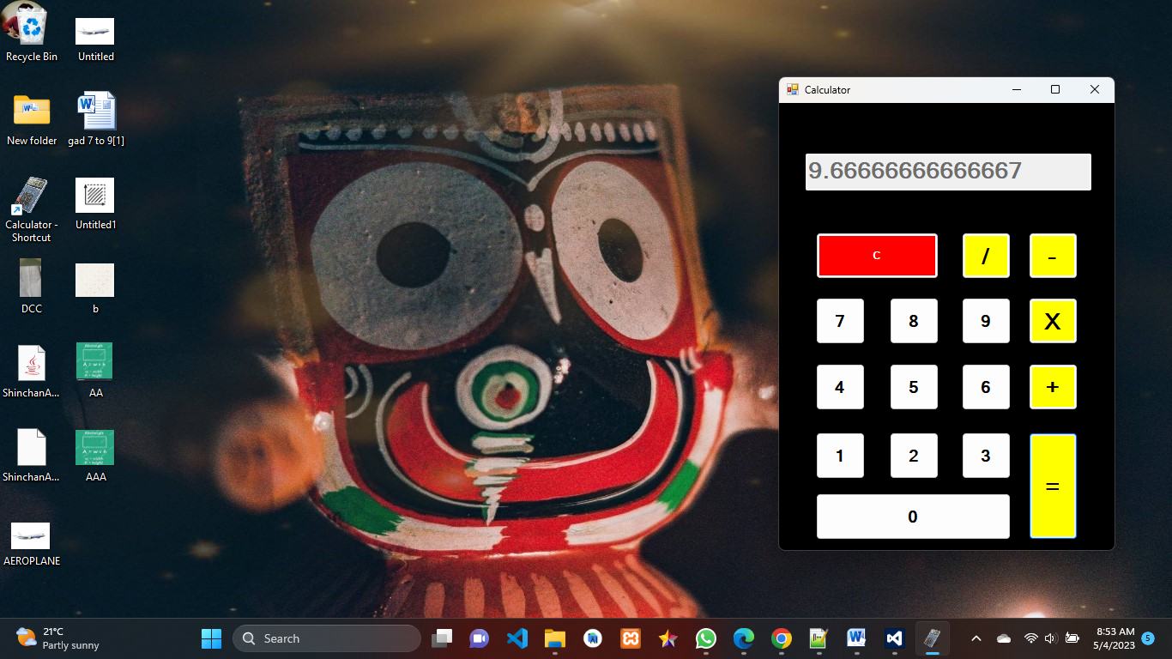

### Skill Developed / Learning outcome of this Micro-Project:

* + How to design form
  + How to use the syntax and various functions of GUI.
  + How to use the vs studio for design and application.
* **Conclusion:**

We have study about various elements in VB.NET GUI like form,button,label,textbox,textarea,picturebox and their properties like backcolor,forecolor,text,font etc

* **REFERENCES**

For this project we refer following websites**: -**

1. [https://www..ijert.org](https://www..ijert.org/)
2. [https://www.nevonprojects.com](https://www.nevonprojects.com/)
3. [https://www.wikipedia.org](https://www.wikipedia.org/)
4. https://www.javatpoint.com